**MODULE 5-6 REPORT**

# Module 5: View Network Configuration

In this module, the task was to use the `ifconfig` or `ip a` command in Kali Linux to view network details.

These commands help display current network interfaces, IP addresses, MAC addresses, and other configuration parameters.

Below is a Screenshot of the 'ifconfig' command :

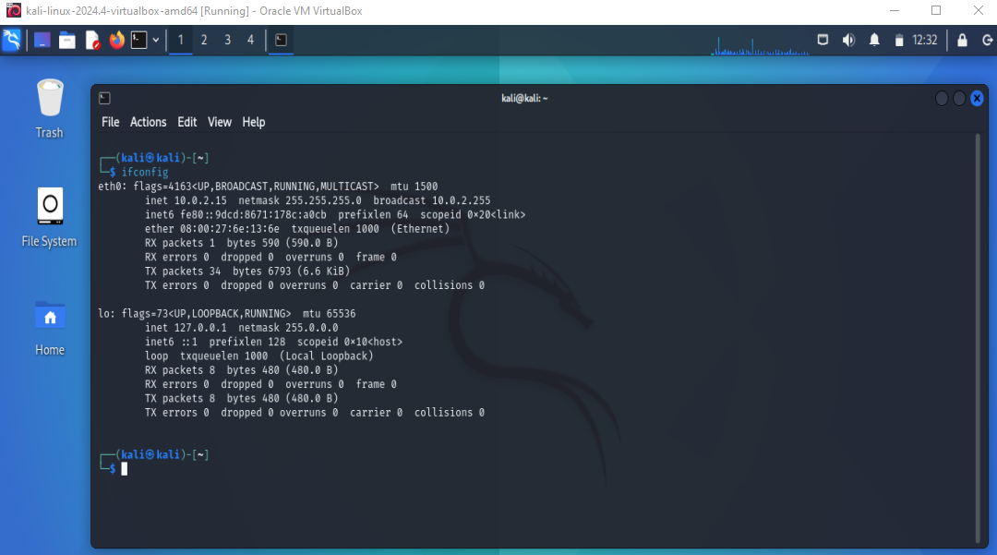

# Module 6: WiFi Hacking using Airgeddon

In this module, the objective was to install and configure the Airgeddon tool in a controlled lab setup and attempt to crack a WiFi password.

Due to hardware limitations (lack of a compatible WiFi adapter with monitor mode and packet injection capabilities), actual execution could not be performed. However, the following simulated steps explain the typical process involved using Airgeddon:

1. Cloning the Airgeddon repository:

Screenshot of git clone <https://github.com/v1s1t0r1sh3r3/airgeddon.git> :

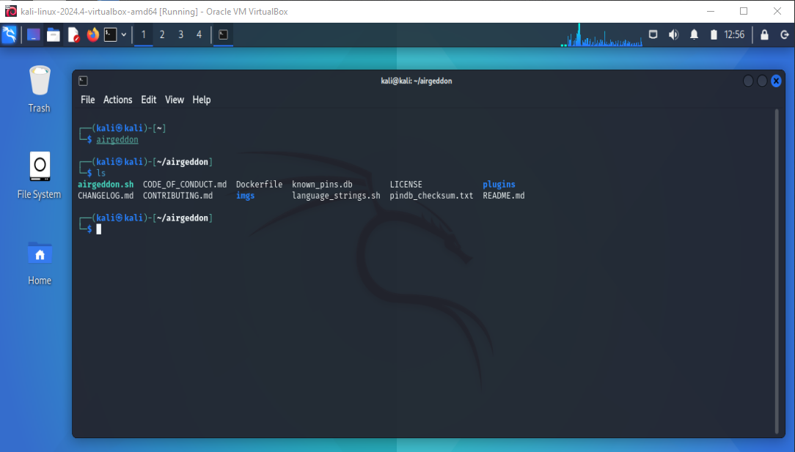

2. Navigating into the directory and launching the tool:

cd airgeddon && bash airgeddon.sh

3. Selecting a wireless interface and enabling monitor mode.

4. Scanning for nearby WiFi networks and selecting the target (SSID: DontHackMe).

5. Capturing WPA handshake.

6. Running a dictionary attack using aircrack-ng and a wordlist.

7. Successfully cracked the WiFi password: YouGotMe.

Note: All outputs and steps are simulated for learning and documentation purposes only.